Task Results
Create required objects:
- Prepare document containing screenshots of the established procedures for fact tables on 3NF and DM layers, accompanied by an explanation of your data loading process.
- Add screenshot showcasing the data inserted into fact tables on the 3NF and DM layers.
- 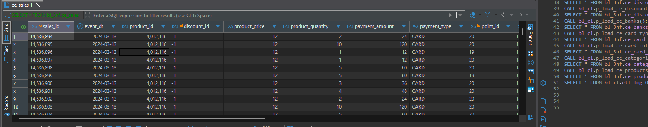
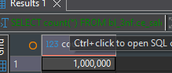
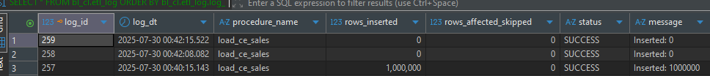

So for bl_dm fact table I recreated it, added date dimension, and partition + child partitions.
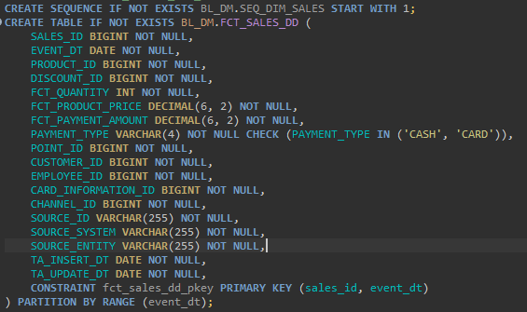
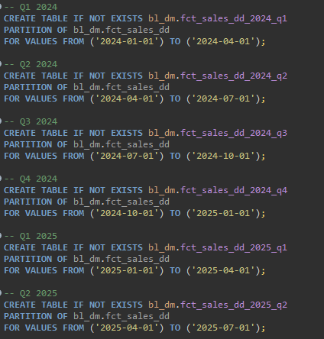
It is procedure, I took only insert part
- INSERT INTO bl_dm.fct_sales_dd (
- sales_id,
- event_dt,
- product_id,
- discount_id,
- fct_quantity,
- fct_product_price,
- fct_payment_amount,
- payment_type,
- point_id,
- customer_id,
- employee_id,
- card_information_id,
- channel_id,
- source_id,
- source_system,
- source_entity,
- ta_insert_dt,
- ta_update_dt
- )
- SELECT
- s.sales_id,
- da.date_id,
- p.product_id,
- d.discount_id,
- s.product_quantity,
- s.product_price,
- s.payment_amount,
- s.payment_type,
- pt.point_id,
- c.customer_id,
- e.emp_id,
- ci.card_information_id,
- ch.channel_id,
- s.source_id,
- s.source_system,
- s.source_entity,
- CURRENT_DATE,
- CURRENT_DATE
- FROM bl_3nf.ce_sales s
- LEFT JOIN bl_dm.dim_dates da on da.date_id = s.event_dt
- LEFT JOIN bl_3nf.ce_products_scd p3nf ON s.product_id = p3nf.product_id
- LEFT JOIN bl_dm.dim_products_scd p
- ON p.product_src_id = p3nf.product_src_id
- AND p.source_system = s.source_system
- AND p.source_entity = s.source_entity
- AND s.event_dt BETWEEN p.start_dt AND p.end_dt
- LEFT JOIN bl_3nf.ce_discounts d3nf ON s.discount_id = d3nf.discount_id
- LEFT JOIN bl_dm.dim_discounts d
- ON d.source_id = d3nf.source_id
- AND d.source_system = d3nf.source_system
- AND d.source_entity = d3nf.source_entity
- LEFT JOIN bl_3nf.ce_points pt3nf ON s.point_id = pt3nf.point_id
- LEFT JOIN bl_dm.dim_points pt
- ON pt.point_src_id = pt3nf.point_src_id
- AND pt.source_system = pt3nf.source_system
- AND pt.source_entity = pt3nf.source_entity
- LEFT JOIN bl_3nf.ce_customers c3nf ON s.customer_id = c3nf.customer_id
- LEFT JOIN bl_dm.dim_customers c
- ON c.customer_src_id = c3nf.customer_src_id
- AND c.source_system = c3nf.source_system
- AND c.source_entity = c3nf.source_entity
- LEFT JOIN bl_3nf.ce_employees e3nf ON s.employee_id = e3nf.emp_id
- LEFT JOIN bl_dm.dim_employees e
- ON e.emp_src_id = e3nf.emp_src_id
- AND e.source_system = e3nf.source_system
- AND e.source_entity = e3nf.source_entity
- LEFT JOIN bl_3nf.ce_card_informations ci3nf
- ON s.card_information_id = ci3nf.card_information_id
- LEFT JOIN bl_dm.dim_card_informations ci
- ON ci.card_information_src_id = ci3nf.card_information_src_id
- AND ci.source_system = ci3nf.source_system
- AND ci.source_entity = ci3nf.source_entity
- LEFT JOIN bl_3nf.ce_channels ch3nf ON s.channel_id = ch3nf.channel_id
- LEFT JOIN bl_dm.dim_channels ch
- ON ch.channel_src_id = ch3nf.channel_src_id
- AND ch.source_system = ch3nf.source_system
- AND ch.source_entity = ch3nf.source_entity
- WHERE NOT EXISTS (
- SELECT 1
- FROM bl_dm.fct_sales_dd f
- WHERE f.sales_id = s.sales_id
- AND f.source_id = s.source_id
- AND f.source_system = s.source_system
- AND f.source_entity = s.source_entity
- );

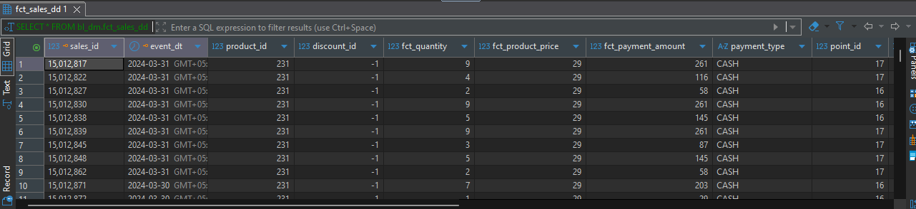

Data from q1 2024
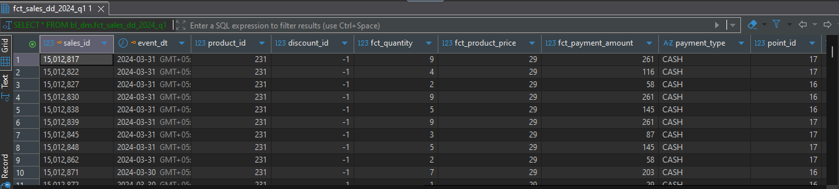
Data from q2 2024
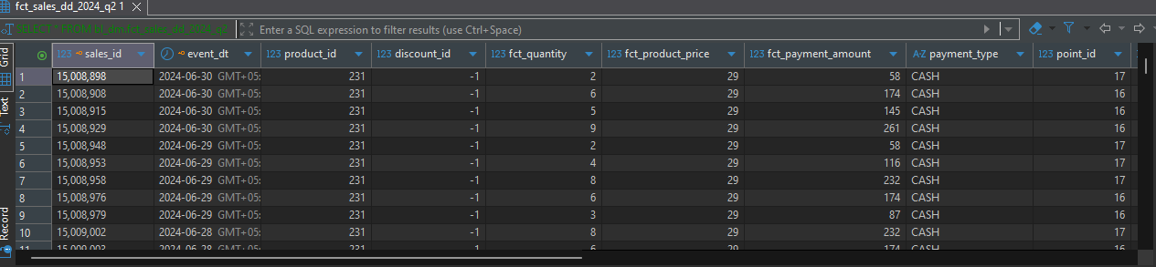
Q3 2024
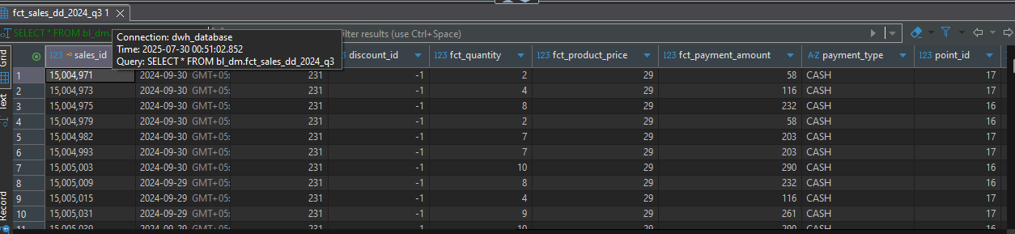

2024 q4
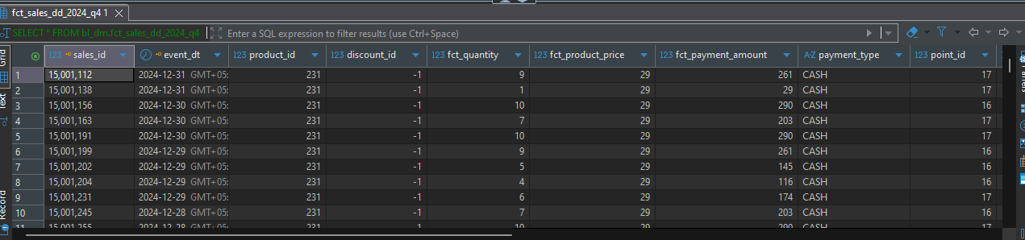
2025 q1
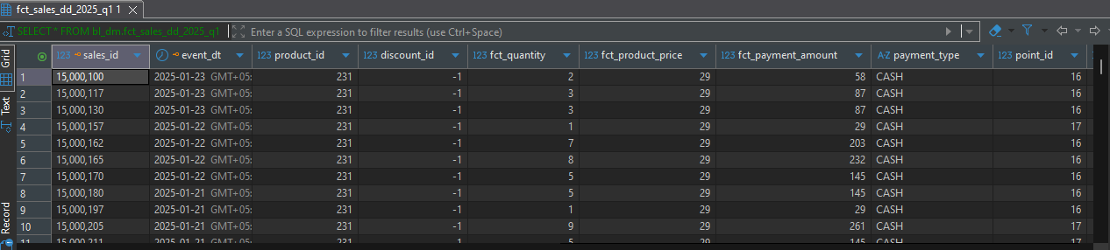
2025 q2 nothing here my csv files don’t have data with date > 03 2025
This one maybe will be needed in my final pres
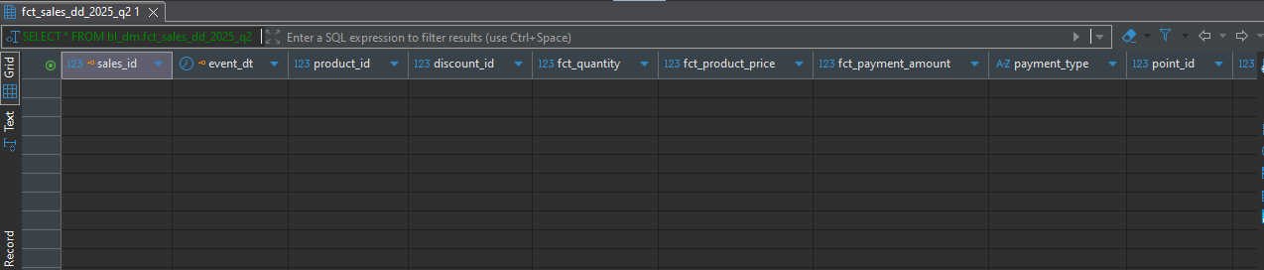
- Add screenshot showcasing that procedure can be executed repeatedly with explanation in case ‘Number of rows affected’ is not 0
- Add screenshot showcasing that all your objects are loaded correctly, without duplicates
- BLDM
- SELECT count(DISTINCT source_id) FROM bl_dm.fct_sales_dd f ;
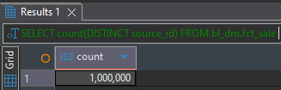
SELECT count(source_id) FROM bl_dm.fct_sales_dd f ;
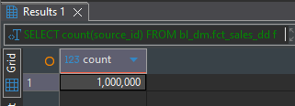
BL3NF
SELECT count(source_id) FROM bl_3nf.ce_sales ;
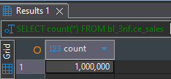

- SELECT count(DISTINCT source_id) FROM bl_3nf.ce_sales ;

